SCHOOLOFCOMPUTER SCIENCE AND ARTIFICIAL INTELLIGENCE |  |  |  |  | DEPARTMENTOFCOMPUTER SCIENCE ENGINEERING
ProgramName:B. Tech |  |  |  | AssignmentType: Lab |  |  | AcademicYear:2025-2026
CourseCoordinatorName |  |  |  | Venkataramana Veeramsetty
Instructor(s)Name
  Dr. V. Venkataramana (Co-ordinator)
  Dr. T. Sampath Kumar
  Dr. Pramoda Patro
  Dr. Brij Kishor Tiwari
  Dr.J.Ravichander
  Dr. Mohammand Ali Shaik
  Dr. Anirodh Kumar
  Mr. S.Naresh Kumar
  Dr. RAJESH VELPULA
  Mr. Kundhan Kumar
  Ms. Ch.Rajitha
  Mr. M Prakash
  Mr. B.Raju
  Intern 1 (Dharma teja)
  Intern 2 (Sai Prasad)
  Intern 3 (Sowmya)
  NS_2 ( Mounika)
CourseCode |  |  | 24CS002PC215 | CourseTitle |  | AI Assisted Coding
Year/Sem |  |  | II/I | Regulation |  | R24
DateandDay  of Assignment |  |  | Week8 - WednesDay | Time(s)
Duration |  |  | 2 Hours | Applicableto  Batches
AssignmentNumber:16.3(Presentassignmentnumber)/24(Totalnumberofassignments)
 | Q.No. | Question |  |  |  |  |  | ExpectedTime  to complete
 | 1 | Lab 16 – Database Design and Queries: Schema Design and SQL Generation  Lab Objectives  - To practice basic SQL query generation with AI assistance.  - To analyze AI-suggested queries for correctness and efficiency.  - To understand how AI can help in documenting and improving database logic.  Learning Outcomes  After completing this lab, students will be able to:  - Use AI tools to design a simple ER diagram / schema for a given scenario.  - Generate CREATE TABLE statements using AI.  - Write and refine basic SQL queries (SELECT, INSERT, UPDATE, DELETE).  - Validate correctness and efficiency of AI-generated SQL.  - Compare AI-generated vs manually written queries.  Task Description #1 – Schema Generation  Task: Ask AI to design a schema for a Library Management System (Tables: Books, Members, Loans).  SQL Code  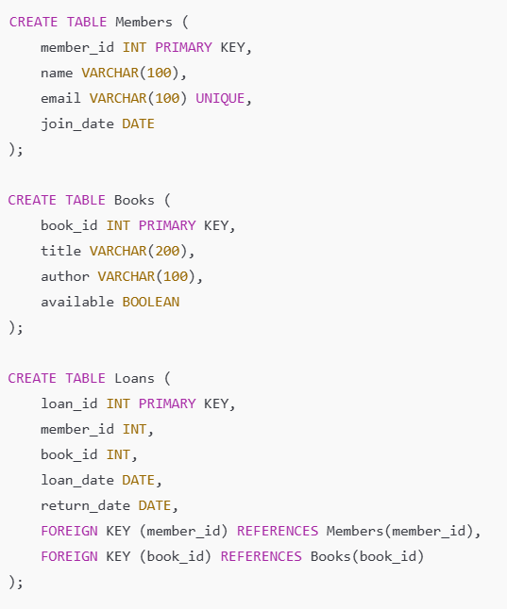  Code:  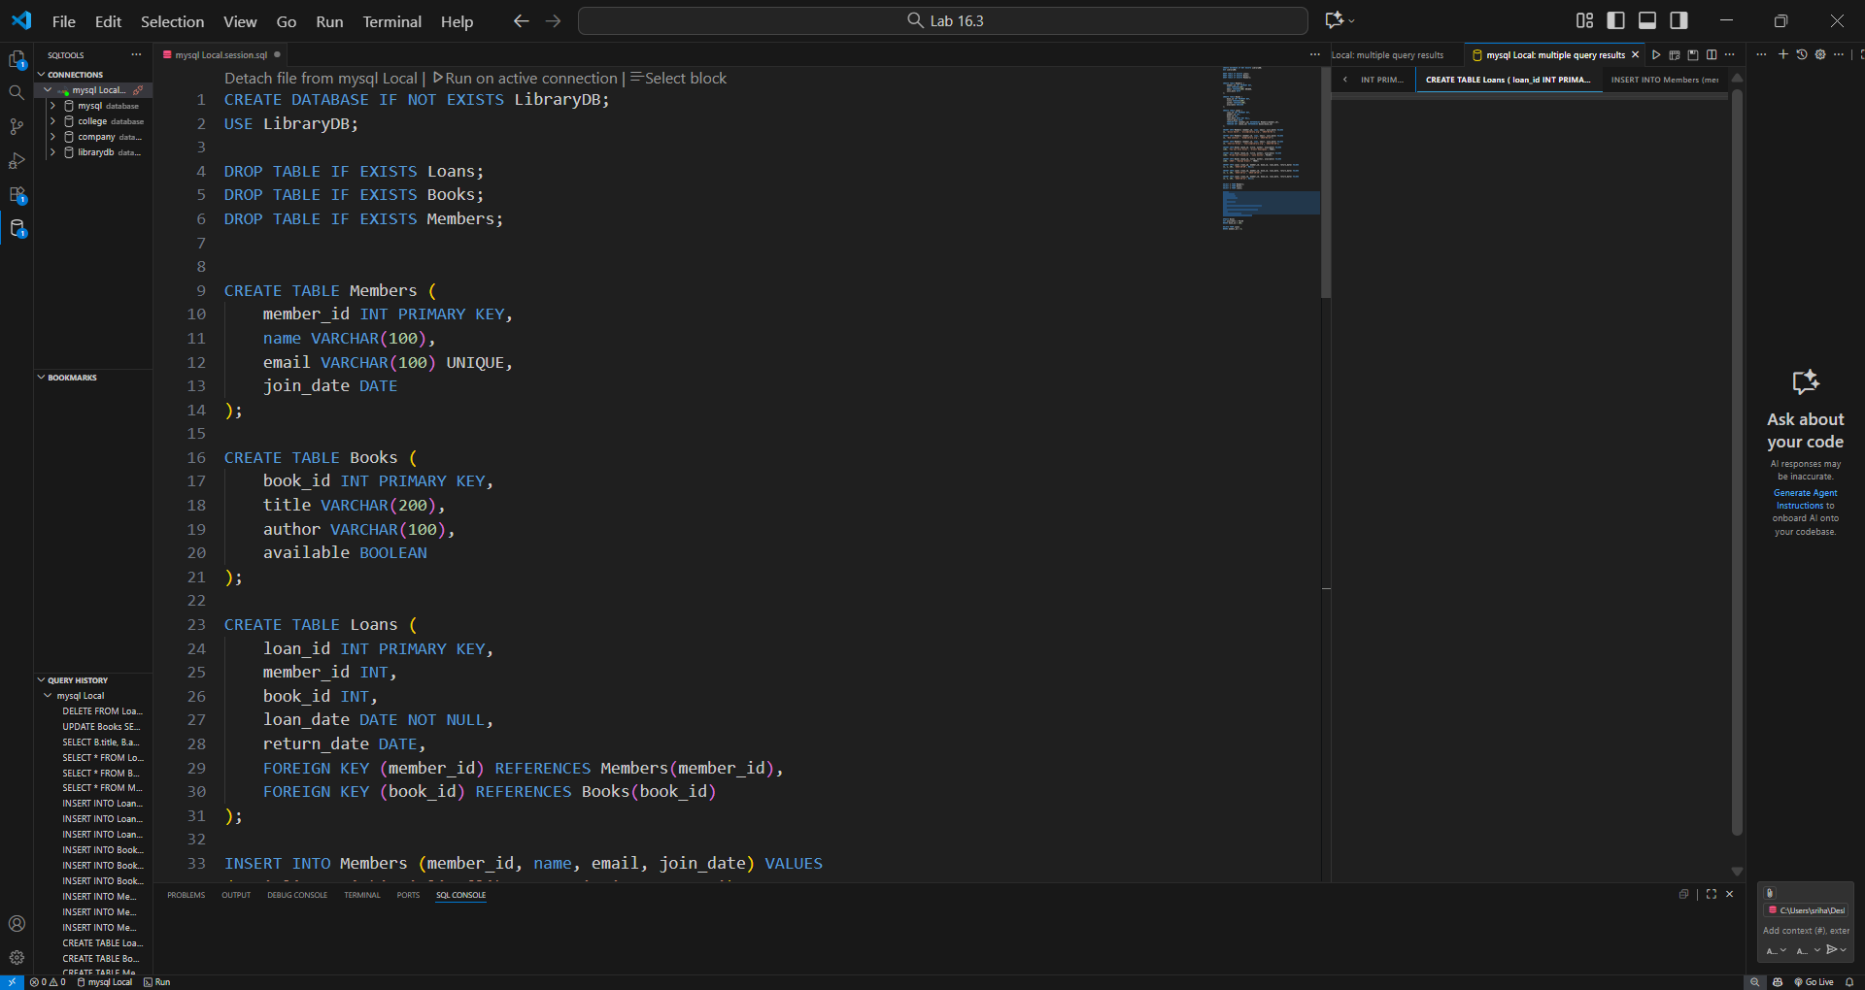  Task Description #2 – Error Insert Data  Task: Ask AI to generate INSERT INTO queries for the schema above (3 sample records per table).  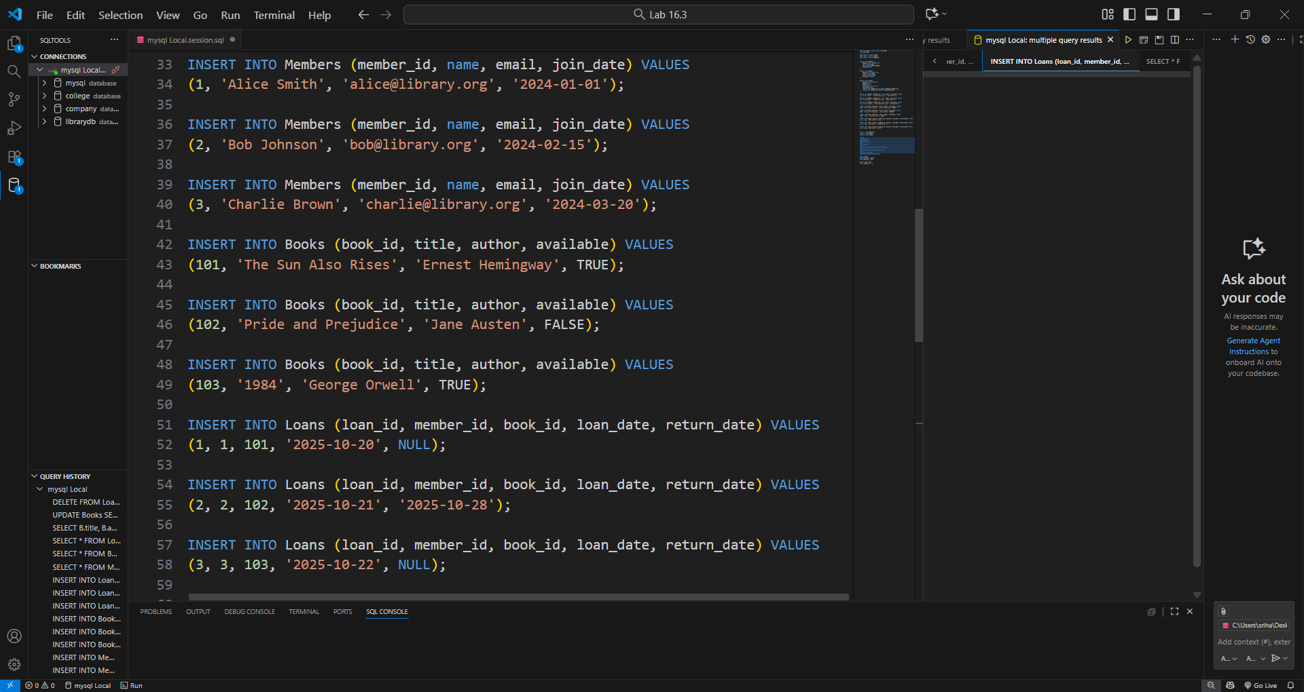  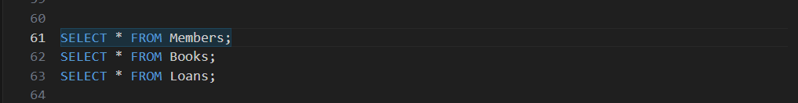  Output:  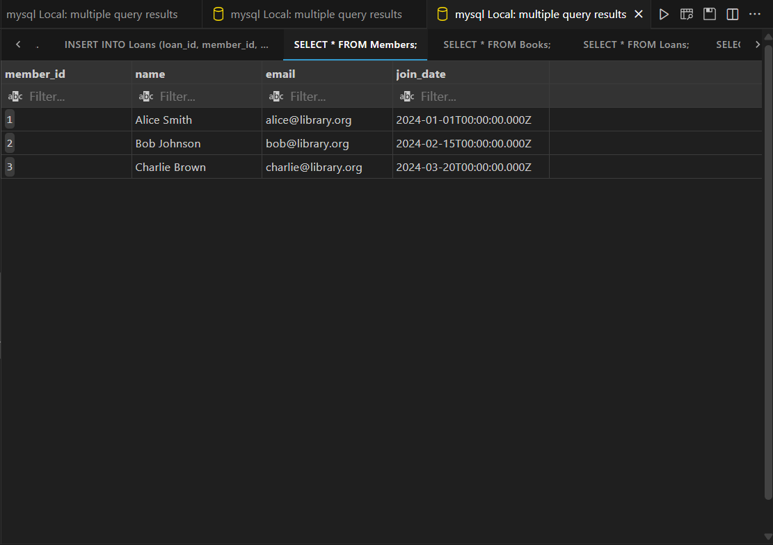  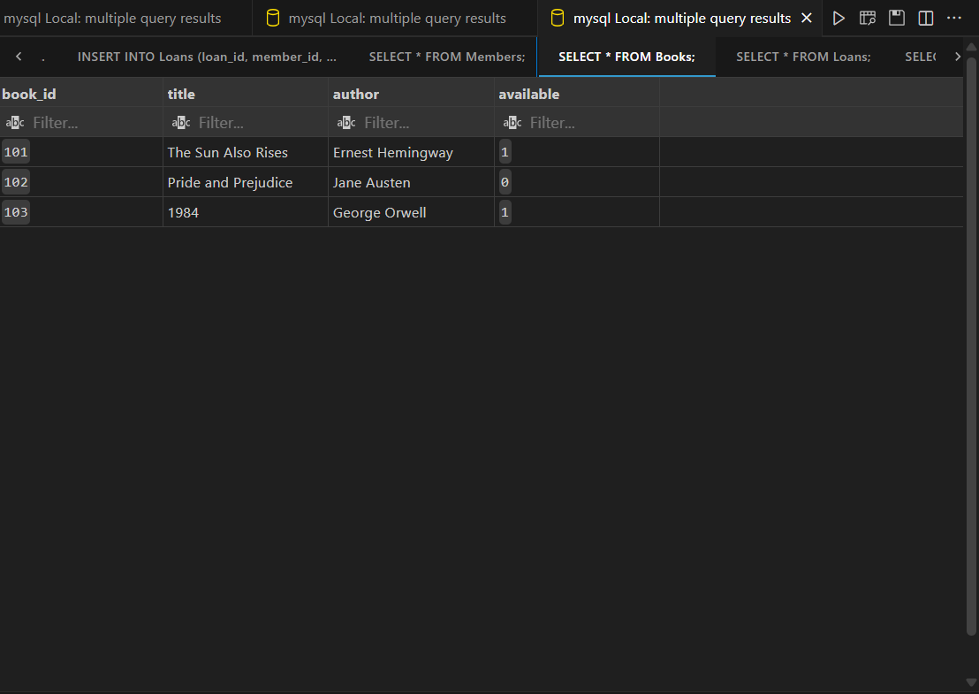  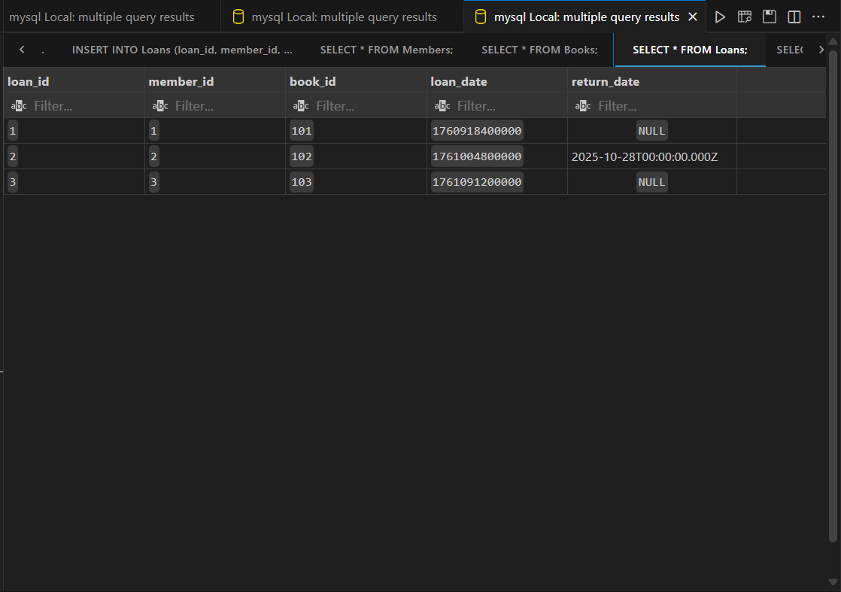  Task Description #3 – Basic Queries  Task: Use AI to generate a query to list all books borrowed by a specific member  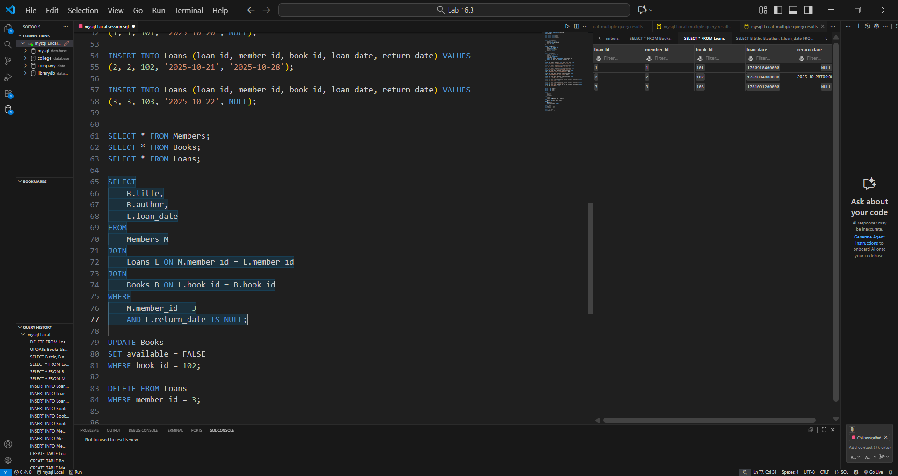  Out put:  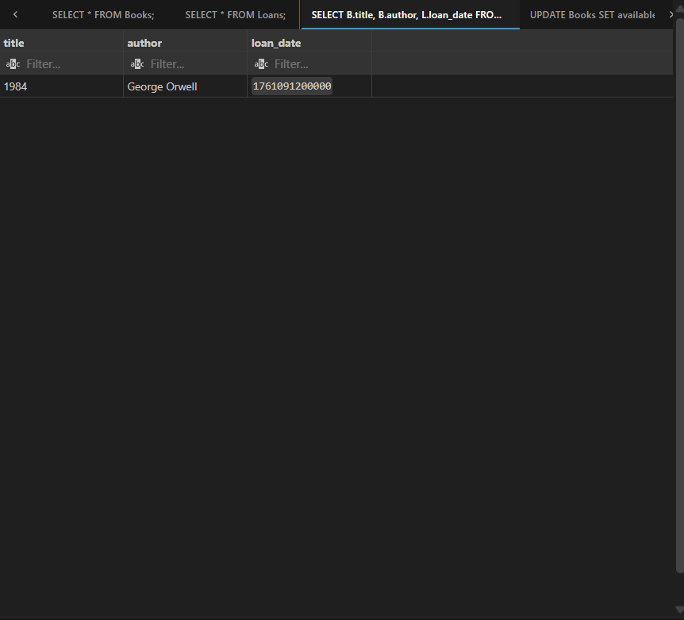  Task Description #4 – Update and Delete Queries  Task: Generate queries with AI for:  - Updating a book’s availability to FALSE when borrowed.  - Deleting a member record safely.  Code:  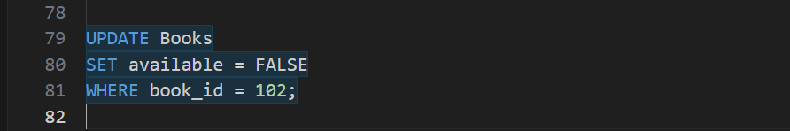    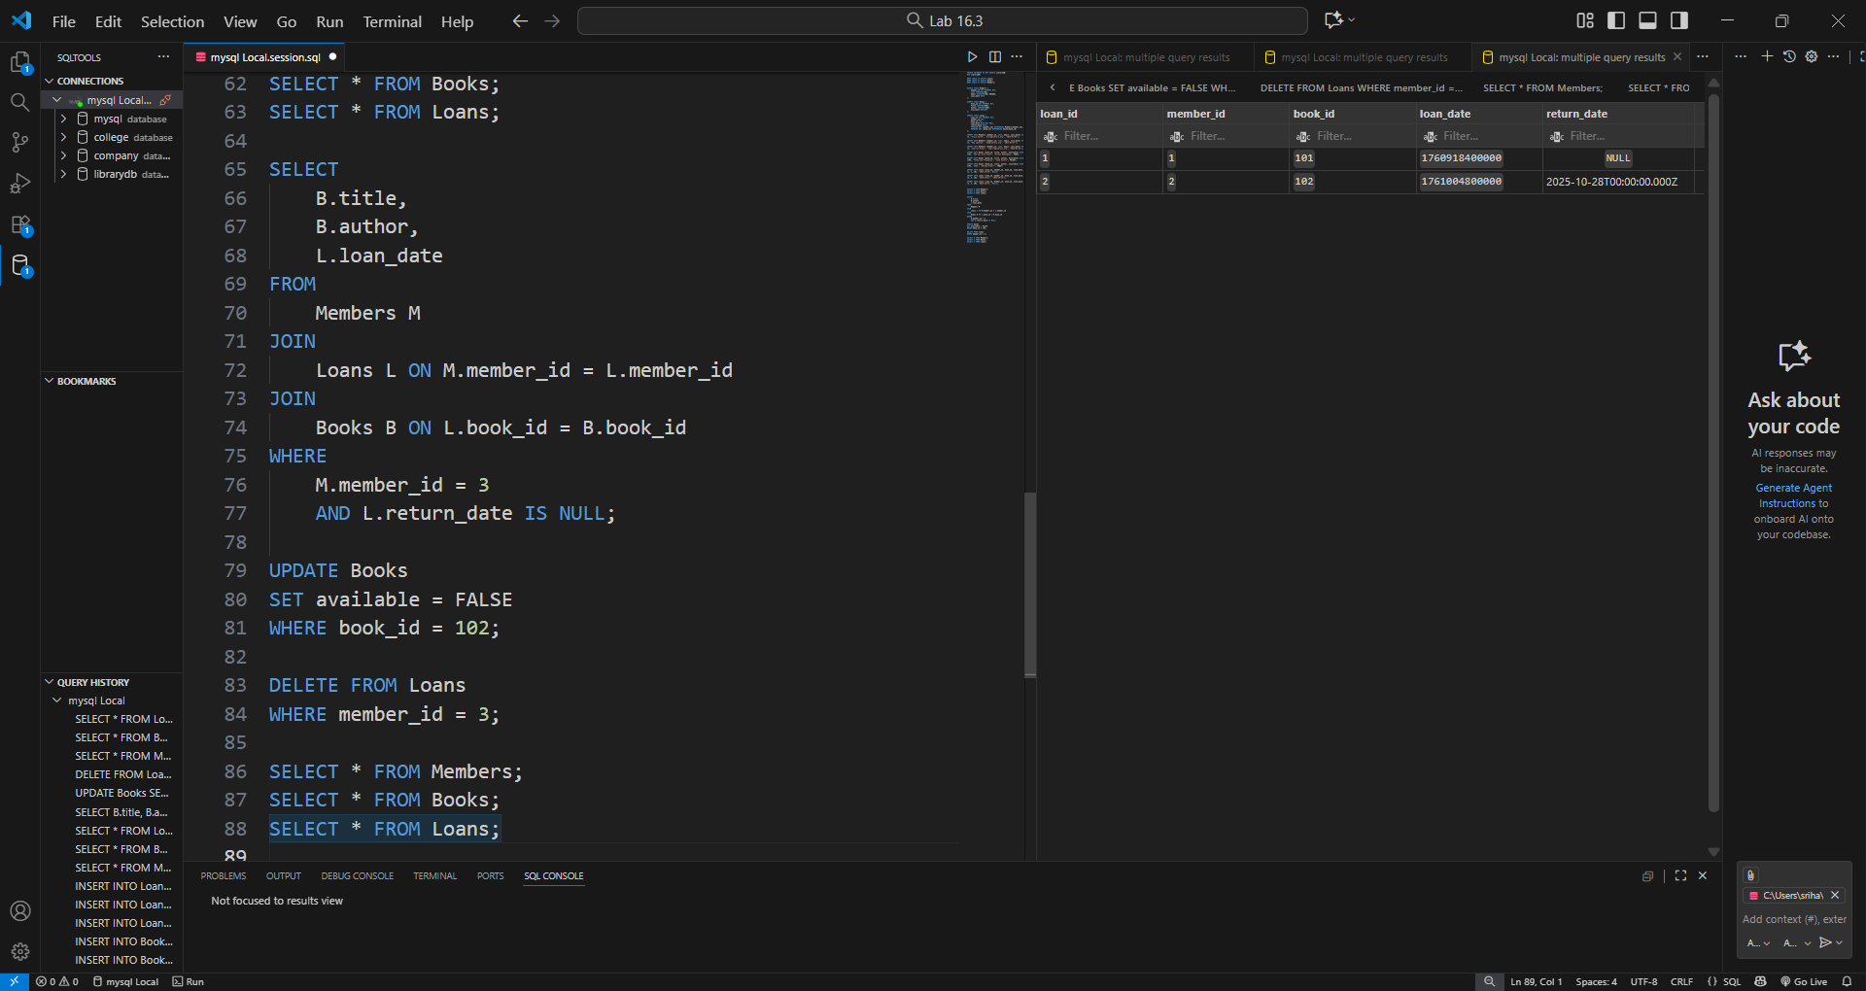  finaltable  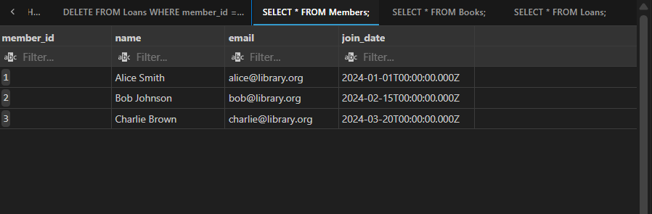  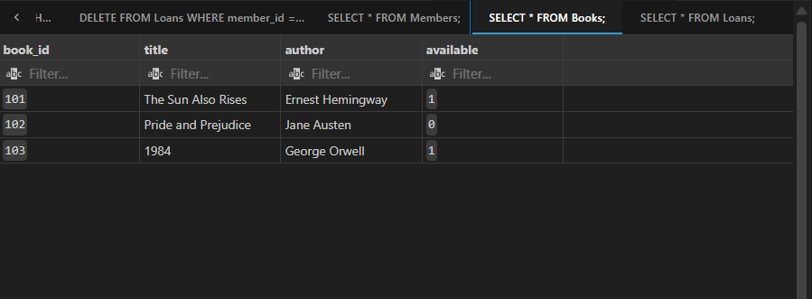  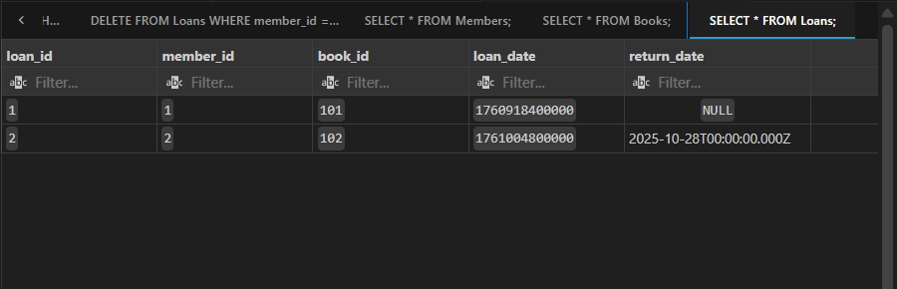 |  |  |  |  |  | Week5 - Monday

